Lab 3 - Create a capacity profile and assign it to the users
Duration: 10 mins

Introduction
In this lab, you will learn how to create and configure a capacity profile in the Copilot Service admin center. Capacity profiles define how many work items an agent can handle and help manage workload distribution efficiently. You will also assign the created capacity profile to a user to control work item assignments.
Task 1: Create and Assign a Capacity Profile
In this task, you will create a new capacity profile, define work limits and reset frequency, and assign the profile to the admin user to manage workload capacity effectively.
- On the Copilot Service admin center, select User management under Customer support.
- 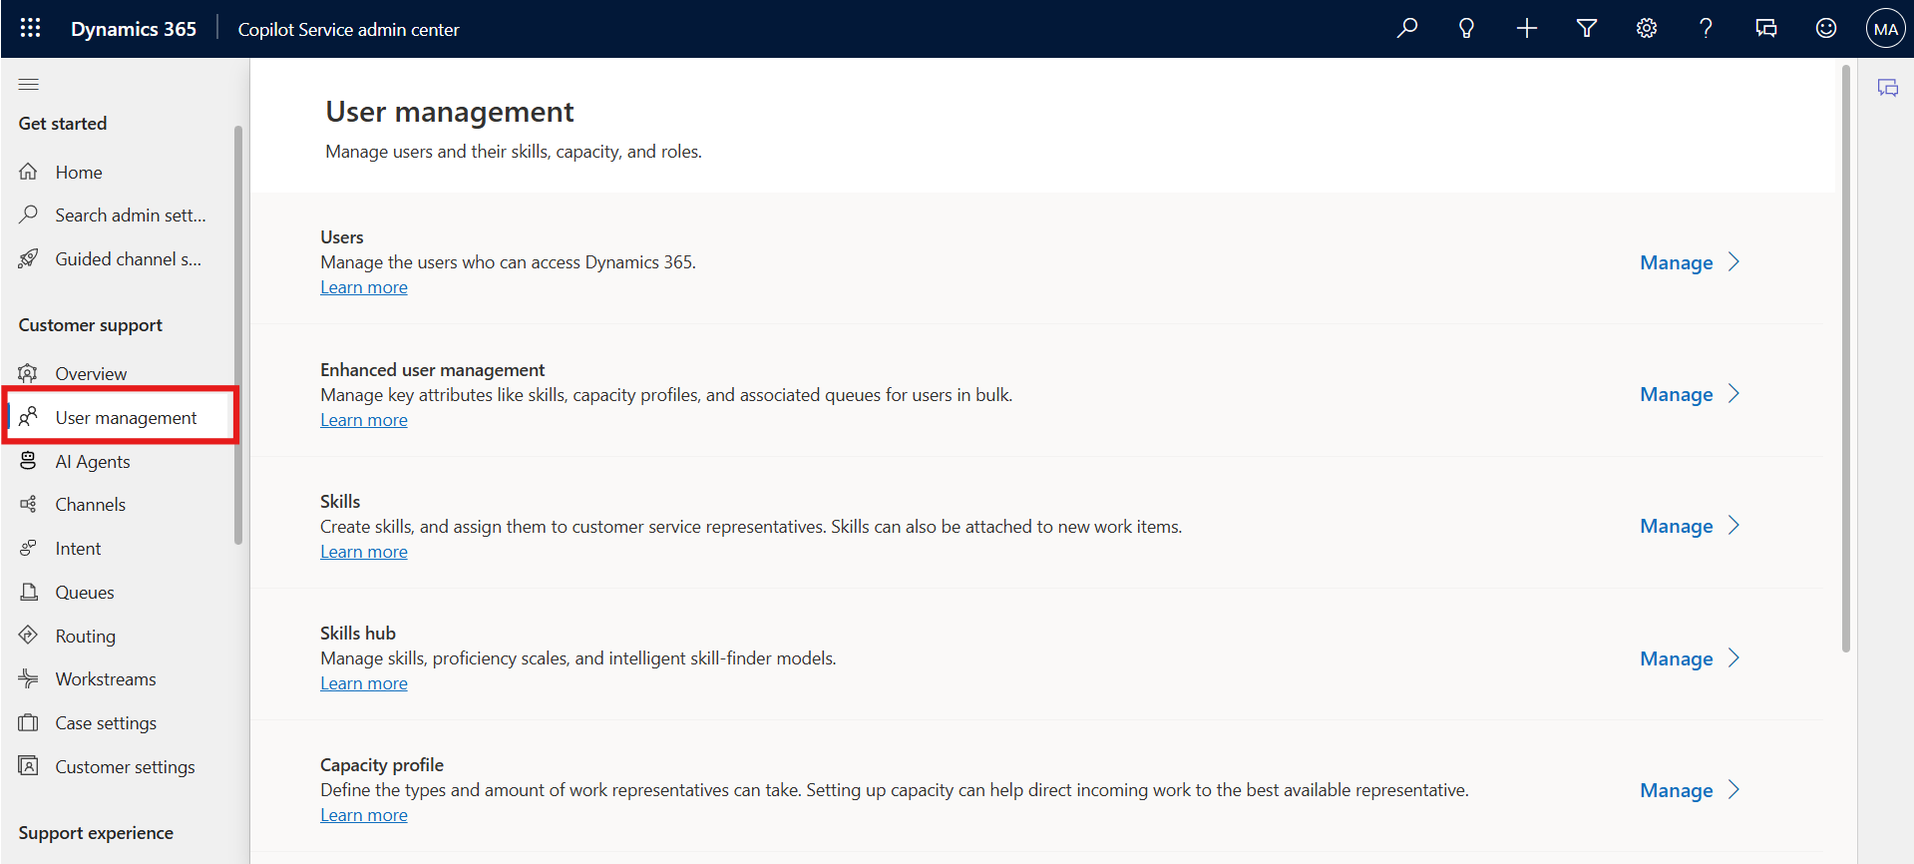
- Select the Manage option for Capacity profile.
- 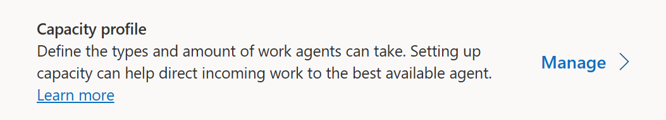
- On the Capacity profiles page, select Create new.
- 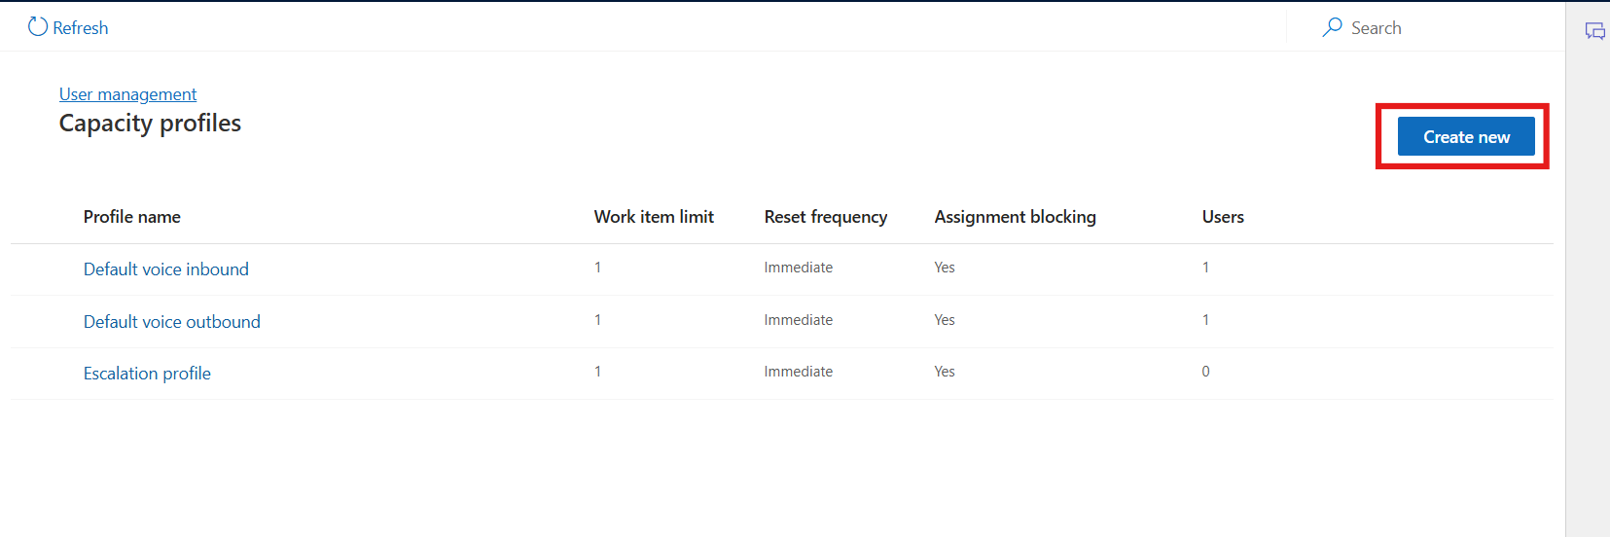
- On the Details tab of the Create capacity profile dialog box, enter the following details:
  - Profile name: Name for the capacity profile as !!Demo!!
  - Work item limit: Number of units of the work type that you can assign to the agent. – Enter - 5
  - Reset frequency: Period after which capacity consumption is reset for agents. Select Immediate
  - Note - Once configured, you must recreate the capacity profile if you want to change the reset frequency.
  - Assignment blocking: Set the toggle to Yes. When the work item limit is met, the agent isn’t assigned a new work item automatically.
- 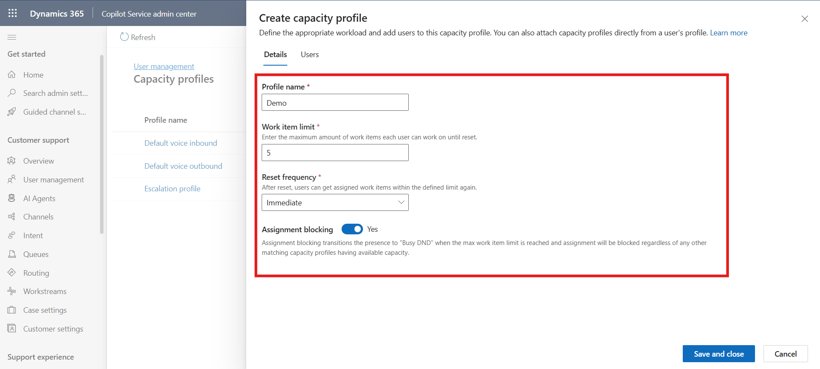
- Select the capacity profile created. Select the Users Tab and Select Add user
- 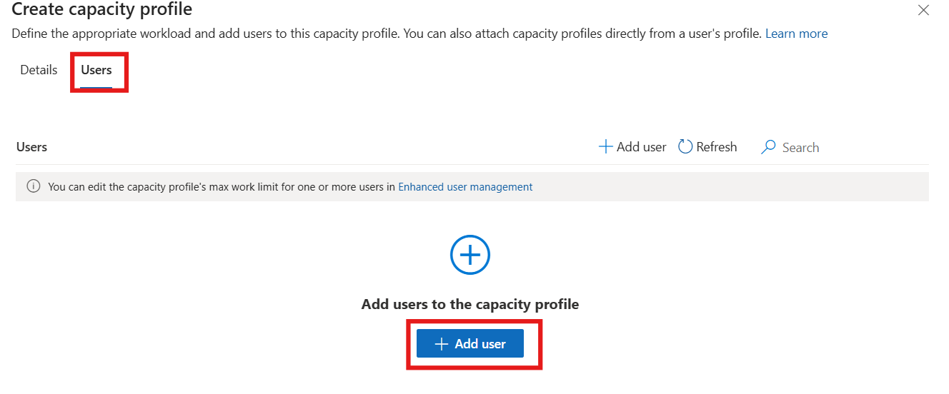
- Select the admin user check box and then click on Add user.
- 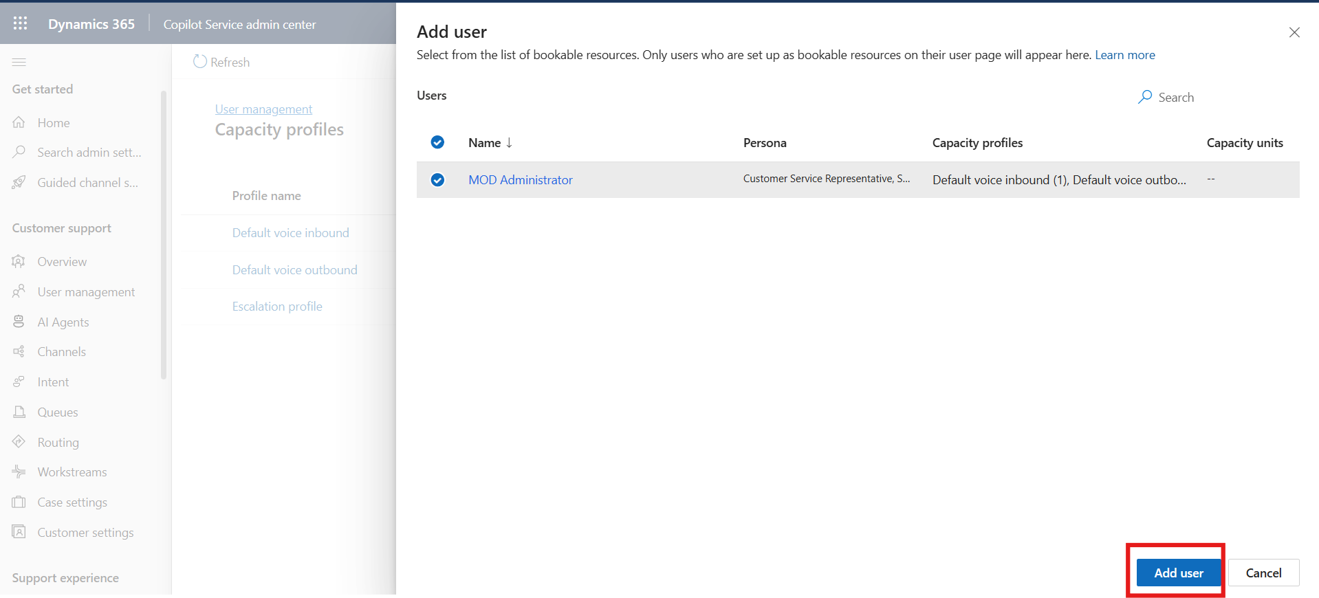
- Select Save and Close. The capacity profile is assigned to the admin user.
- 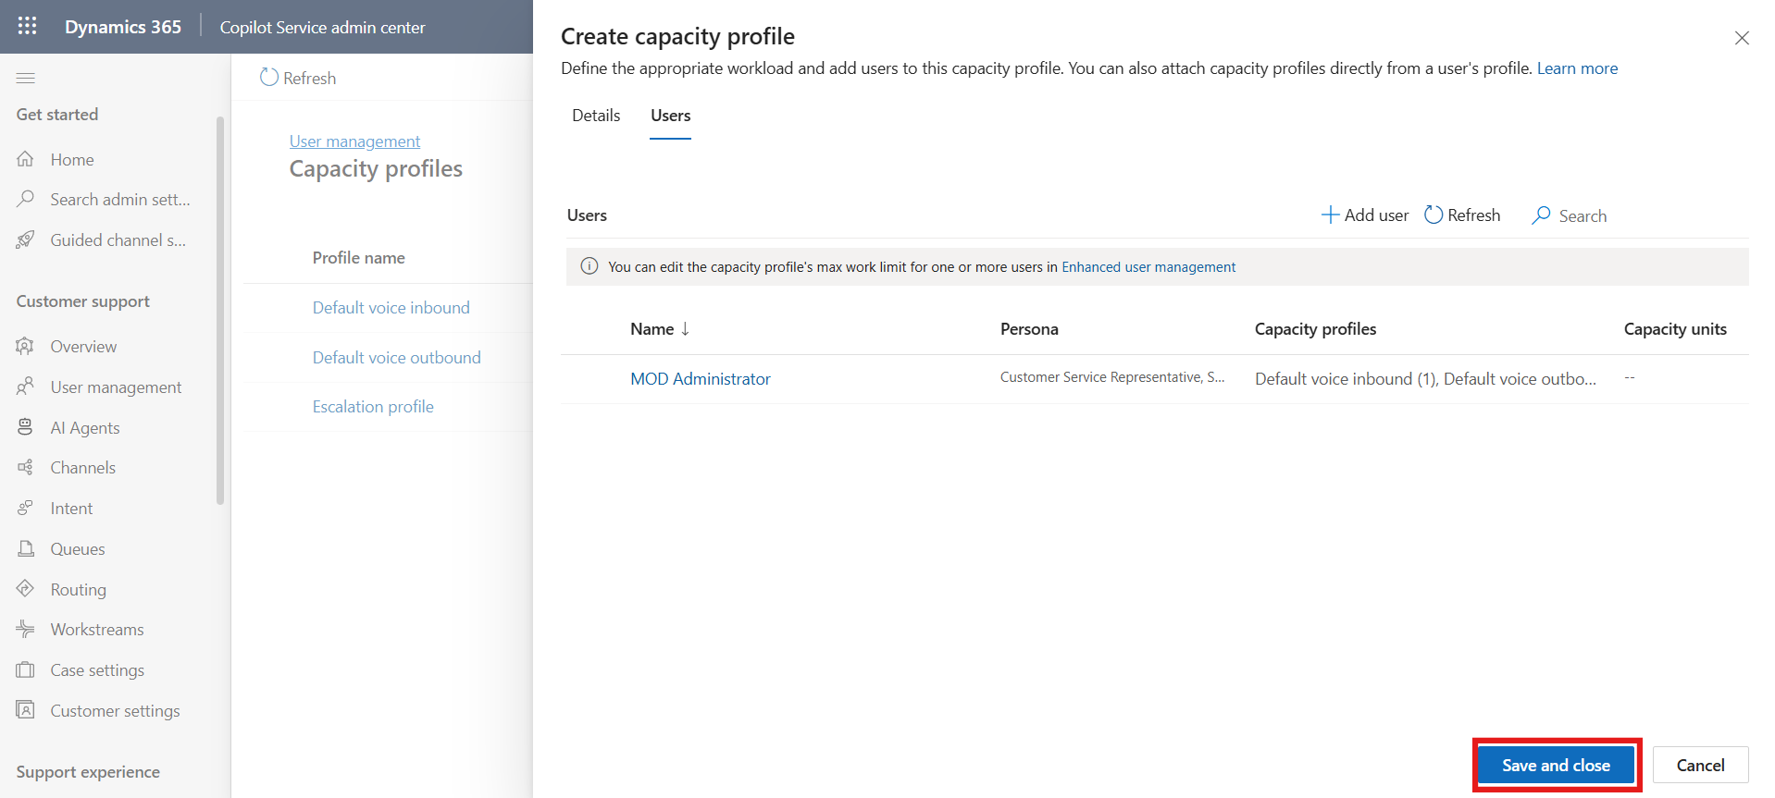

Conclusion
By completing this lab, you have successfully created a capacity profile in the Copilot Service admin center and assigned it to a user. This setup helps ensure optimal workload management and prevents agents from being over-assigned tasks beyond their defined capacity.

